# Chapter-1

# Introduction

.

Human scientific progress since the start of the 19th Century has been accelerating exponentially as we have moved from the agricultural and the industrial ages, to the computing and information age. Every decade we make more scientific progress as a species than humans had in the previous 1000 years.

An important factor in this growth is our ability to conceptualize and think ahead, which allows us to plan forward for when our technological abilities are eventually able to catch up to our theoretical ideas. A strong example of this would be humanity’s recent efforts to become an interplanetary civilization. With government agencies such as NASA and ISRO as well as private entities such as SpaceX making massive strides to take the first steps in moving humanity to Mars. Understanding the red planet and it’s areography (i.e., the study of Mars’ geographical features) has become a pivotal area of interest to ensure that we can be prepared for the eventual colonization of the red planet. Knowing the location of mineral resources, topographical features such as valleys, plains, depressions and elevations, as well as their correlation to features on earth can help us both understand the history of Mars as well as give us a guide to our future on it.

This goal of understanding Mars is being achieved through Martian probes, satellites and rovers that collect enormous amounts of data about the planet that is then processed, analysed and scrutinized to give us a clearer understanding of the planet in its present, past and future stages as each correlates with the other. Data about the composition of the soil, erosion patterns, land formations and the presence of liquid water or ice as well as the atmospheric composition can tell us a lot about how Mars was, millions of years ago. This led to questions such as if life ever existed on the red planet and if so, what happened to it, if life is still present how would we co-exist with it, and if there are conditions on the planet unknown to us that may make any attempts at colonization completely futile. All of these questions need well informed decisions to be made before any human lives are risked on a mission.

In the past these inferences had to be made through tedious manual observations or complex calculations which had to be programmed with a specific test case in mind, however there has been a paradigm shift in the way in which the data is being analysed in the past few years that can expedite our study of Mars.

With the introduction of machine learning and neural network-based methodologies, the process of inferences from the huge amounts of data that are being collected has become more practical and efficient. These techniques and algorithms can be utilized in every stage of the data processing and analysis stack. From error connection applications at the data sources such as satellites and probes, to algorithms that can help us extract more information from pre-existing hardware frameworks such as image upscaling, colorization etc. They also help with processing large amounts of data passively and having an autonomous framework that can classify, summarize, and find patterns in the data that can then be studied by humans have greatly increased the efficiency of the data pipelines in many industries. This technology can be utilized in the domain of areography as well.

This project is built with the aim to implement image processing techniques, machine learning and convolutional neural networks on open source, multi-spectral, satellite imagery of Mars obtained from NASA’s THEMIS(Thermal Imaging System) initiative as well as ISRO’s MOMISDC (Mars Orbiter Mission ISRO Science Data Archive) to obtain feature maps, locations of potential interest and spectral emission based mineral deposit maps that can help in mapping out areas of potential interest to future expeditions stream lining the MARS exploration process.

Also, this project intends on mapping and classifying the topology of Mars and comparing the results with that of Earth’s topology which would provide us with insight into possible locations for colonies, artificial reservoirs, arable land etc. that will be pivotal in colonizing the planet. It would also build a framework through which scientists can study the areological processes of Mars similarly to those on Earth by correlating topology and hence the processes that give rise to them.

This project aims to build a deeper understanding of the Martian surface and uncover the remnants of topographical features that may have been eroded and withered away with time, helping us understand the planets complicated past, through data about its present so that the scientists can learn and plan for our eventual future as its new inhabitants.

## **1.1 Overview**

Give a brief overview of the work

## **1.2 Literature survey**

1. **Geographical Area Mapping and classification utilizing Multispectral Satellite Imagery Processing based On Machine Learning Algorithms, Apurva Saksena, Anushka Ringshia, Arnnava Sharma, Aparna Halbe.**

In this paper, a technique for classifying geographical area on vegetation, impervious surfaces and soil; is proposed, which is accomplished by machine learning algorithms. Classification is done for various types of land uses, residential, commercial, recreational, agricultural etc. Here, pre-processed images, with high resolution are used for classification. Normalized difference vegetation index (NDVI) index is used to analyse remote sensing measurements and assess whether the target is green vegetation or not. ArcGIS software is used for image masking, where the image pixel intensity is set to zero according to the mask and the masking operations performed. The support-vector-machine algorithm is used to classify in the spatial analyst toolbox of ArcGIS software. The machine is trained to classify the land based on attributes of land use, like, commercial, agricultural, industrial etc. The final output shows the map obtained by masking the land-cover map into categories like agricultural, commercial, industrial etc. and providing them with respective colour codes to differentiate. The accuracy is measured by considering all the retrieved instances and relevant instances and finding the similarities between them. Some drawbacks include, NDVI index saturates at high biomass content making it difficult to differentiate moderately high plant cover from high plant cover. This project utilizes this classification concept to classify and map the Mars dataset based on different attributes.

1. **A Lightweight CNN Architecture for Land Classification on Satellite Images, Gourab Patowary, Meenakshi Agarwalla, Sumit Agarwal, Manash Pratim Sarma.**

This paper proposes an unsupervised machine learning method for land classification, lightweight CNN architecture [contains less attributes, efficient in terms of time saving, requires less storage space, provides good accuracy]. Here, SAT4 and SAT6 open-source data sets are used. Where SAT4 has 500,000 images with four types of landscapes, SAT6 has 405,000 images with six classes of landscapes. Different landscapes include trees, water bodies, agricultural fields etc. These images have four channels namely, Red, Green, Blue and Near Infrared [NIR]. The proposed architecture includes 13 layers with each convolution layer having 3*3 kernel except 11th and 12th layers which have 1*1 kernel. The 2*2 kernels are used for pooling operations. The kernels of the first hidden layer compute huge feature information from the input, hence richer in information compared to input satellite image which consists of RGB and NIR bands with pixel values ranging from (0,0,0,0) to (255,255,255,255). To perfectly extract the increasingly richer and richer information from previous hidden layers, more kernels are used. The dataset has compressed images which may contain lots of noise; hence the model learns noisy information, this is called overfitting. Dropout technique is used to avoid overfitting problems. The final results are having an accuracy of 99.47% on the dataset.

1. **Random Forest Data Cube Based Algorithm for land cover classification: A Colombian Case, Indira Pachon, Saloman Ramire, Diana Fonseca, Pilar Lonzano-Rivera, Christain Ariza, Maria Puala Mancipe.**

This paper describes implementation of machine learning algorithm RF on the Colombian data cube [CD Col] infrastructure using the land cover classification at the Colombian Orinoquia natural region, its result and assessment. The training data was collected in 7 classes; urban area, water, crops etc. Sample datasets consisted of 3780 polygons achieved from on ground and visual interpretation delineated over the calculated median temporal compound. Storage unit is a Landsat 8 OLI sensor. The required bands to calculate the median temporal composite (blue, green, red, NIR, SWIR1, SWIR2). First, the training polygons were uploaded to the CD Col. Then, polygons were rasterized to get the training pixels. RF classification model was created training the algorithm by random selection of pixels from every thematic class on the calculated median temporal compound. Training RF classification model for trees was accomplished by following Boulesteix’s rule, where values of trees were given in a range with 50 intervals, and model error stabilization was observed around 500. The accuracy assessment is based on analysis of the confusion matrix and the kappa index of agreement. The confusion matrix is a square array of dimension n*n, where n is the number of classes. A sample of 400 pixels was selected according to a stratified random sampling based in the total area proportion occupied by each class. Then the associated label from RF classification was extracted, and the confusion matrix and kappa were calculated.

1. **Detection of Minerals Through the Processing of Satellite Images, Edgardo Lozano-Cortrina, Erik Berrospi-Elises, Avid Roman-Gonzalez.**

This paper proposes a method to detect minerals such as Lead Sulphide and Zinc Oxide in the desired area utilizing multispectral satellite images. The dataset used is obtained from the ASTER satellite, which provides multispectral images. The development was done in four steps; Acquisition of satellite images. Transformation and recognition of image, JPG images were converted to TIF format as 14 spectral bands were required. Processing of images and calculation of total area with minerals, here image processing techniques are used, the spectral bands are superimposed to obtain zones of the city containing these required minerals. Spectral signatures of the elements are first identified, the reflectance and absorption values are also known, from this data, the final result can be obtained. To establish the relation between the affected area and the total area, it's necessary to know the area of the city, once the data is known, the affected area is found in km2. The accuracy of the results depends on the resolution of the obtained images, where higher resolution images give more accurate results. A library ‘Eco stress Spectral Library’ is used to obtain spectral signatures of the elements, this library also contains spectral signatures of many other elements as well. Drawbacks include, there are repetitions of spectral signatures depending on the medium in which they are found, this could cause variations in the calculations made using these data.

1. **Gradient-Based Adaptive Image Super Resolution, Achmad Junaidi, Chao-Hung Lin, Yi-Hsing Tseng, Li-Hsueh Chang, Shin-Chia Peng.**

This paper proposes an image super-resolution [SR] scheme by introducing a dynamic weighting to gradient prior to adjust to various types of conditions in the SR process. The general flow of the scheme, the low-resolution [LR] input will be calculated for variance and mean value, and the variance to mean [VMR] ratio will be produced which will correlate to the weighting of the gradient, this obtained weight value will be used for the next SR process.

The VMR ratio is calculated using a specific formula, initially a map describes the visualisation of the point pattern. To describe the point pattern quantitatively, two approaches are used, based on points density and points separation. Point Density approach using Quadrat Analysis based on observing the frequency distribution or density of points within a set of grid squares. Point interaction approach using Nearest Neighbour Analysis based on distances of points one from another. The first approach examines first order effects and the second approach examines second order effects. VMR ratio has the following characteristics; for uniform distribution variance is zero, for random distribution the variance and the mean are same and for the clustered distribution the variance is relatively large. Adaptive gradient means the gradient value can be changed according to image conditions whether the image is a homogenous area or not. Its value can be changed through weight or lambda value. A homogenous area such as water area needs a bigger lambda value to smooth and reduce the noise, a non-homogenous area needs a smaller lambda value to strengthen the gradient to get sharper edges. VMR value is used to define homogeneity, under some conditions, the VMR value that involves the variance are finite, stating that the averages of samples of observations of random variables independently obtained from independent distributions converge in distribution to the normal. To satisfy this condition, Gaussian Normal Distribution to correlate VMR value and lambda is used. This technique can be utilized to improve the resolution of the obtained satellite images.

**1.3 Aim / Problem statement / Scope / Objective of the project work**

We decided to undertake this research project as our entire team shared interest in both image processing and astronomical research. ISROs recent Mangalyaan and Chandrayaan mission were a major catalyst in sparking our interest in the field of satellite image processing.

The ISRO’s MOMISDC open-source data set gave us the idea to perform image analysis to study Mars’ topography. Research was started on papers that had performed similar analysis on satellite imagery of earth, and found methodologies that could be implemented on Mars as well, to study its geographical features, classify them, map interesting features across the planet as well as to find resource deposits on Mars.

**1.3.1 Problem statement**

Mars exploration through satellites started in the year 1971, satellite images are being analyzed and studied from then. At present, scientists are analyzing the mars satellite images in many different ways to get various information from it, such as weather patterns, topography, ice caps etc. but, the research depends on the extent of analysis performed on the obtained images. Since, scientist and engineers do more research in these areas, they require more detailed analysis of these images to progress in the research. Many have tried to solve this problem in different ways, like analyzing the water routes to find the suitable location for exploration missions. These methods have yielded good results, and more methods are being researched to improve the analysis. The progress in future exploration missions depend on this type of analysis and research, where is not advanced can limit the outcomes of future missions. The aim of this project is to provide a unique data analysis of Mars satellite images, which can used for further progress in research.

**1.3.2 Scope of the Project**

1. To build a model that can detect patters on the surface of Mars that are similar to the patters of the earth.
2. To be able to detect minerals deposits on Mars using the satellite images.

**1.3.3 Objectives of the Project**

**Objective 1:**

Gradient Descent based upscaling of Mars Multi-Spectral Satellite imagery, and stitching of scaled images to form high resolution maps of the planet.

**Objective 2:**

Area mapping and Classification of Martian topography with the help of unsupervised Neural network algorithms applied to satellite imagery.

**Objective 3:**

Anomaly detection, clustering and classification of aerographical features of interest on the Martian surface.

**Objective 4:**

Correlation testing of landform and relief features on Earth to those on Mars, to find similar topographical features

**Objective 5:**

Spectral signature based mineral deposit mapping of the Martian surface, to detect various resource deposits that will be important for future MARS exploration.

**Objective 6:**

Listing and mapping of coordinate locations of particular locations of interest that may be useful to explore in future Mars mission

**1.4 Methodology**

## Methods going to be employed to solve the project problem has to be depicted

## **1.5 Organization of the project report**

The project work undertaken by us is organized in the following sequence as follows.

A brief introduction to the work was presented in the introductory chapter in chapter-1. Block diagram and working principle of project work undertaken by us is presented in the chapter – 2. Hardware/ Software tools /Description/Interfacing employed in our project work is depicted in the chapter – 3. . ………….

:

:

Finally, the report concludes with the conclusion and future work in chapter –6.

Appendices, Data Sheets, Program codes, Catalogue Sheets, Papers presented (a copy of the presented paper with the certificate) are presented at the end of the project report one after the other in succession.

# Chapter 2

# Block diagram, Circuit Diagrams and Working principle, Algorithms, Flow-Charts & DFDs

Fig. 1 : Block-diagram of the proposed methodology

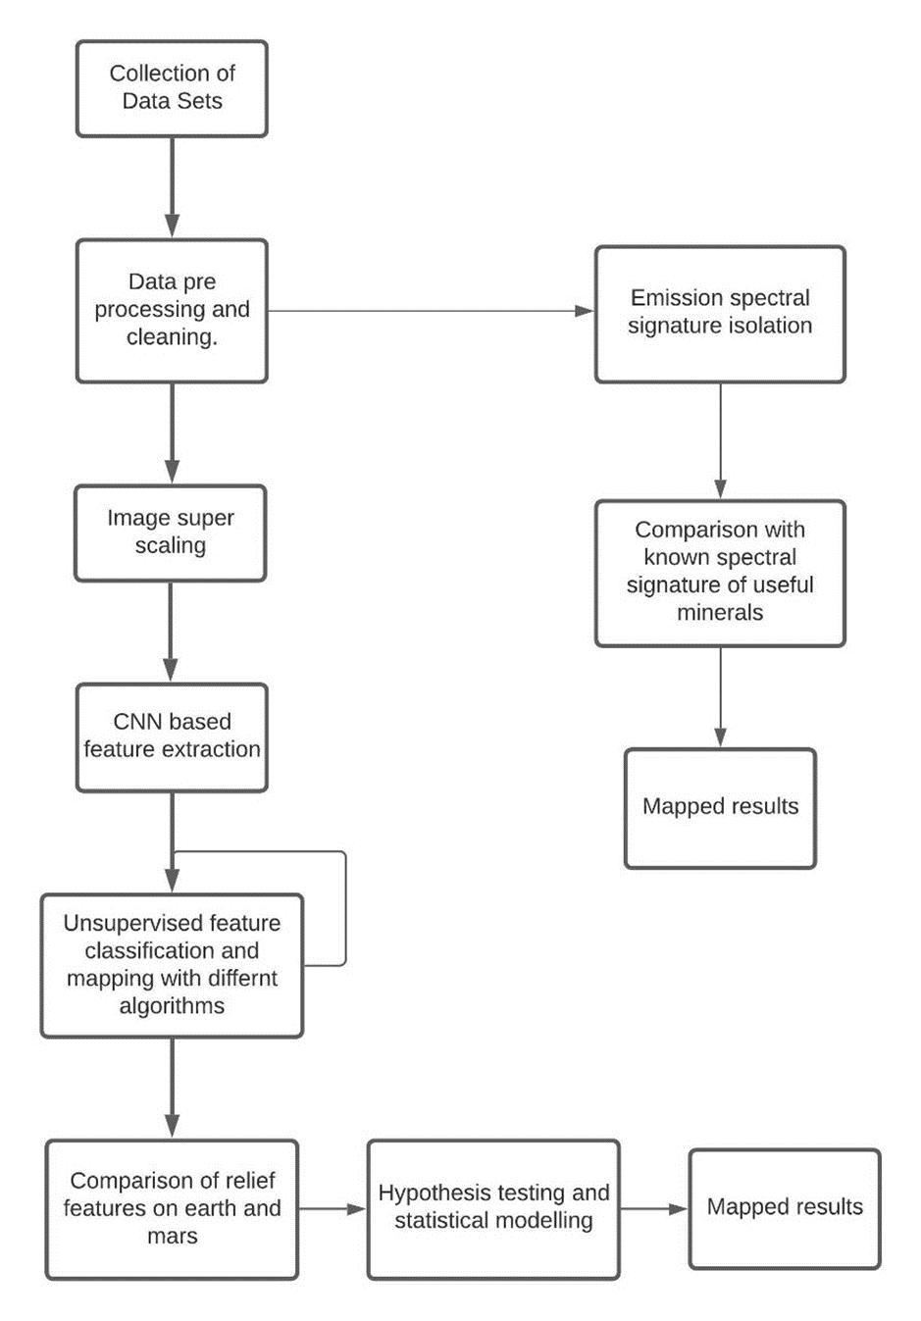

Fig. 2 : Circuit Diagram

Fig. 2 : Algorithm used

Fig. 3 : Flow-chart of the methodology used

# Chapter-3

**DATA SET**

The dataset for this project is taken from the Planetary Data System (PDS) which is a distributed data system that [NASA](https://en.wikipedia.org/wiki/NASA) uses to archive data collected by [Solar System](https://en.wikipedia.org/wiki/Solar_System) missions. It is a Free to Use data library under US Government's Technology and Software Publicly Available (TSPA) classification.

The Planetary Data System (PDS) is an active repository that makes well-documented, peer-reviewed planetary data available to the scholarly community. The data is collected from orbital, landing, and robotic missions, as well as ground-based support data. It is managed by NASA Headquarters' Planetary Sciences Division. The primary goal of the PDS is to preserve a long-term planetary data repository so that future generations of scientists can access, comprehend, and use pre-existing planetary data. The PDS aims to assure archive compatibility by adhering to specified storage media, archiving formats, and needed documentation criteria.

To classify standard data products that will be produced from remotely sensed data from NASA's Earth Observing System, NASA defines a set of processing "levels." The idea was that the level of any output product would indicate the type of data processing used to create it, allowing the user of that product to determine what applications it should be used for. Each level was given a brief definition by NASA.

The CODMAC and NASA data processing levels are categorized in the table below:

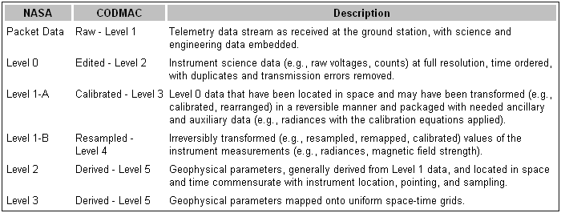

**Level 0:**  Instrument data collected by the sensor in its raw form. Unless the focus of interest is on the sensing instrument itself rather than the features recorded in the data, data in this state is not that useful.

**Level 1A:** This data has been rectified for detector variations across the sensor by using equalization functions among the detectors to level the sensor's values. The absolute calibration coefficients in this radiometric adjustment can then be utilized to transform the digital quantities into irradiance values.

**Level 1B:** The next stage is to apply measurable corrections to the image to address systematic geometric distortions that occur when some sensors capture the image. Other sensors that do not suffer from systematic geometric error do not require this level. It's also worth noting that 1B data cannot be used to restore level 0 data.

**Level 2A:** These photos have been mapped into a standard cartographic map reference system in a systematic manner. The term "geo-referenced" is used to describe items that are nominally geo-referenced but do not have a high level of accuracy.

**Level 2B:** A more rigorous process including significant user input is required to improve the spatial accuracy of an image. An image analyst geo-registers the image through the process of image rectification by identifying precise places in the image that match highly well-defined geographic locations known as ground control points. Except in places of significant local topographic relief, the image is geo-referenced accurately to the spatial resolution of the original data - in other words, it is limited only by the spatial resolution of the sensor - once this processing is accomplished.

**Level 3:** To produce a more realistic spatial representation in locations with a lot of height relief, such as mountainous areas, additional corrections are required. Orthorectification has been applied to Level 3 data, which corrects for image distortions caused by topography relief, lens effects, and camera tilt. Level 3 data has a consistent scale and is suitable for usage on large grid scales.

**Software :**

The software tool used for the project work is (list out the relevant ones with details…)

Matlab with Simulink modeling

LabVIEW Scilab Microcontroller language Microprocessor language

KIEL C/C++ coding Java VB Excel

HDL/VHDL/Cadence/Mentor graphics/Synapsis

Ansys PSpice

etc…

:

:

**Note :** Mention in brief how *u* have used the tool to suit your defined problem.

# Chapter-4

**Super Resolution**

The task of reconstructing high-resolution photographs from one or more low-resolution observations of the same scene is known as super-resolution (SR). The image reconstruction technique provides a mechanism for rectifying imaging system flaws. The SR can be categorized into single image super-resolution (SISR) and multi-image super-resolution (MISR) depending on the number of inputs LR image (MISR). Because of its high efficiency, SISR is far more prominent than MISR. Because a high-perceptual-quality HR image contains more valuable features, it is frequently used in a variety of fields, including medical imaging, satellite imaging, and security imaging. In the typical SISR framework, as depicted in the LR image y is modeled as follows:

y = (x ⊗ k)↓s + n,

where x⊗k is the convolution between the blurry kernel k and the unknown HR image x, ↓s is the down sampling operator with scale factor s, and n is the independent noise term. Solving the equation is an extremely ill-posed problem because one LR input may correspond to many possible HR solutions.

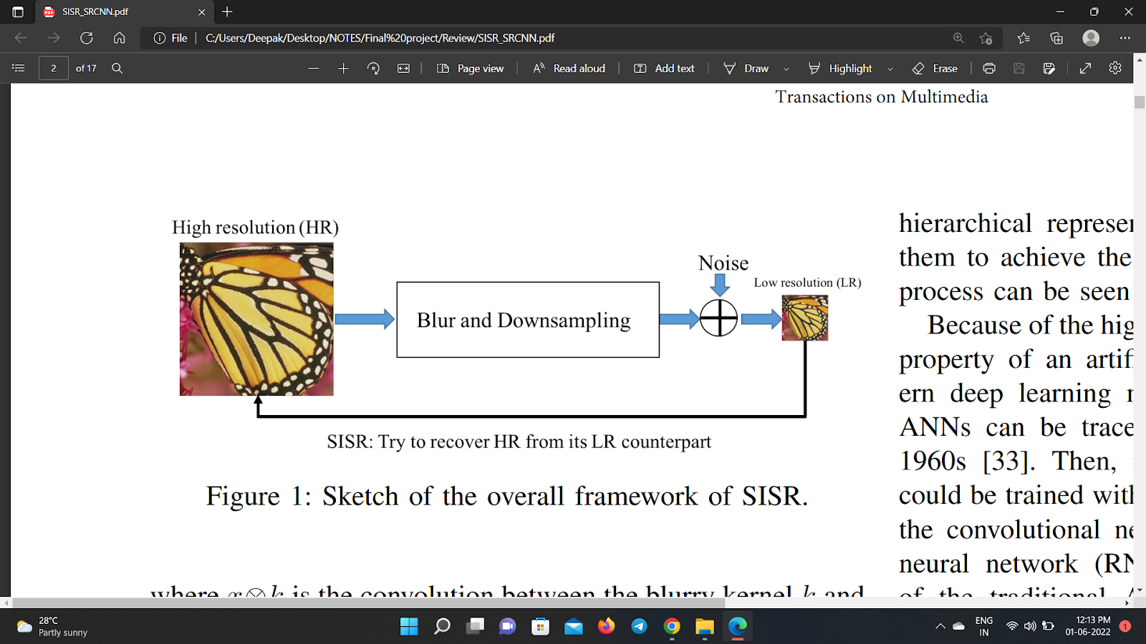

As with many other computer vision problems, SR can be approached through the lens of deep learning convolutional neural networks (CNNs), which have now outperformed traditional SR algorithms that relied on mathematical processes that tried to smoothly interpolate the known pixels of an LR image to those of an HR image. These mathematical methods are the equivalent of a convolution with a kernel independent of the image. These methods, lack in performance and produce overly smooth images with a loss of detail, to counteract this we utilize CNNs that learn kernel states with non-linear activation functions to encode high dimensional features into simplified filters that represent general characteristics about the images that can add structure lost in the low-resolution input.

Additionally, the super-resolution of satellite images poses more problems that need to be addressed. Since CNNs were introduced to tackle 8-bit RGB images, satellite image products that are generally calibrated to represent a physical unit, such as surface reflectance or absolute radiance have to undergo various pre-processing steps such as depth reduction, color space conversion, etc. in order to make them suitable to feed into

the model. Satellite images are also prone to high degrees of variance due to physical conditions such as haze, clouds, and cloud shadows as well as land cover characteristics that vary globally to a high degree.

# 4.1 Super-Resolution Convolutional Neural Networks (SRCNN)

The SRCNN is a deep convolutional neural network that learns end-to-end mapping of low resolution to high resolution images. As a result, we can use it to improve the image quality of low-resolution images. We implemented SRCNN in order to improve the quality of the output images, as measured by peak signal-to-noise ratio (PSNR). The input to our algorithm is a mars satellite image, which we feed through a convolutional neural network (CNN) in order to produce a high-resolution image.

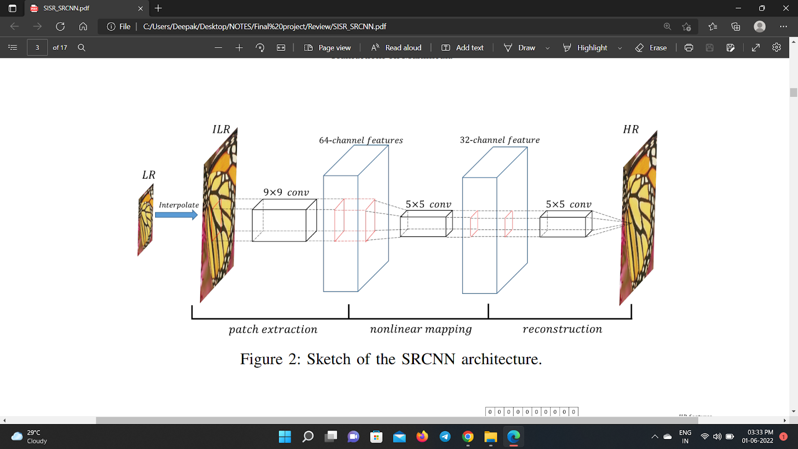

Figure depicts the entire architecture of SRCNN. For simplicity, SRCNN simply implements the luminance components for training, as is the case with many older approaches. SRCNN is a three-layer CNN, where the filter sizes of each layer are 64 × 1 × 9 × 9, 32 × 64 × 5 × 5 and 1 × 32 × 5 × 5. The mean square error (MSE) is the loss function for optimizing SRCNN. SRCNN has a basic formulation and can be thought of as a regular CNN that approximates the complex mapping between the LR and HR spaces in an end-to-end manner. The SRCNN model has three nonlinear functions:

* Patch extraction
* Nonlinear mapping and
* Reconstruction.

1. **Patch Extraction and Representation**

The first layer performs a standard convolution with ReLU to get $F_{1}(Y)$ that is a set of feature maps of the image:

$$F_{1}(Y)=max(0,W_{1}*Y+B_{1})$$

where $W_{1}$ is the weight kernel, whose size is given as $Size of W_{1}= c×f_{1}×f_{1}×n_{1}$, and $B_{1}$ is the bias vector whose size is $B_{1}=n_{1}$. Here $c$ is the number of channels of the image, $f_{1}$ is the filter size, and $n_{1}$ is the number of filters in the first layer. In our case $c=1, f_{1}=9,n_{1}=64.$

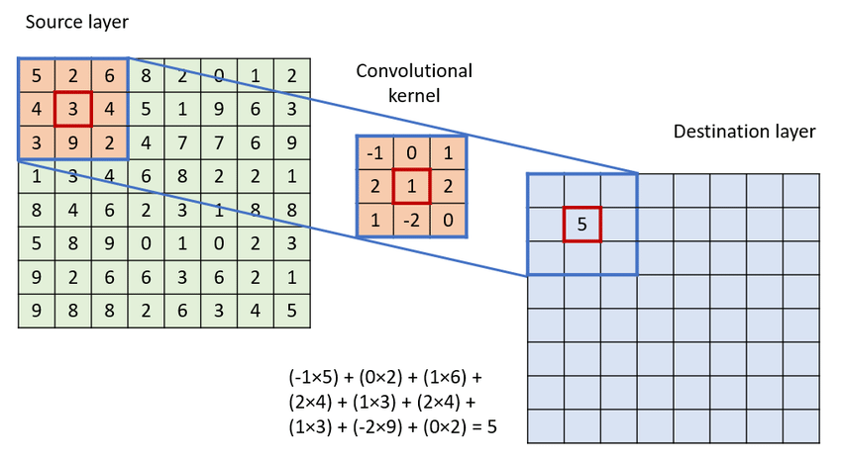

1. **Non-Linear Mapping**

The second layer performs a non-linear mapping which is a dimension reducing method which attempts to retain the distances between data points as well as possible:

$$F_{2}(Y)=max(0,W_{2}*F_{1}(Y)+B_{2})$$

where the $Size of W_{2}= n_{1}×f_{2}×f_{2}×n_{2}$, and the size of $B_{2}=n_{1}$. Here $c$ is the number of channels of the image, $f_{1}$ is the filter size, $n_{1}$& $n_{2}$ is the number of filters in layers 1 and 2 and in our case ${f2=1,n}_{1}=64 \& n_{2}=32.$ This 1×1 actually is a convolution suggested in Network In Network (NIN).

1. **Reconstruction**

The final layer is responsible for reconstructing the image, by performing another calculation as:

$$F_{3}(Y)= W_{3}*F_{2}(Y)+B_{3}$$

where the $Size of W_{2}= n_{2}×f_{3}×f_{3}×c$, and the size of $B_{2}=c$. Here $c$ is the number of channels of the image, $f_{2}$ is the filter size of the third convolution layer and $n_{2}$ is the number of filters in layer 2 and in our case $f_{3}=5,c=3,n_{2}=32.$

**Loss Function**

We calculated MSE over each of the 3 image channels which was used to compare how far away the target image’s pixels are from the predicted/generated image’s pixels. The mean of each pixel’s difference is taken and then squared. It is calculated using the equation. Our model utilizes MSE as its loss function to guide its training.

$$L\left(Θ\right)=\frac{1}{n}\sum_{i=1}^{n}{{\left\|F\left(Y_{i};Θ\right)- X_{i}\right\|}^{2}}$$

**Reconstruction**

After mapping, we need to reconstruct the image. Hence, we do conv again.

$$F\left(Y\right)= W_{3}* F_{2}\left(Y\right)+ B_{3}$$

The third layer

Size of W3: n2×f3 ×f3×c

Size of B3: c

# 4.1.1 Experimental Model

**Datasets**

Since no standard dataset of Mars satellite images exist for super-resolution, we improvised and created a training set of 1000 images. For this, we utilized the DoMars16k dataset which is a diverse dataset for weakly supervised classification of landforms on Mars. It contains 16150 hand-labeled images derived from the raw near-infrared images taken by the Mars Reconnaissance Orbiter’s HiRISE camera. The dataset consists of images with dimensions of 200px * 200px, representing 15 unique classes of landforms on Mars. This gave us a diverse enough set of images to provide our algorithm with enough varied data to perform well on most images. We chose 1000 images at random from the dataset and split it into a train, test, and validation set ratio of 8:1:1.

**Implementation Details**

Our model is built with internal parameters: number of input channels (c): 3, number of layer 1 feature maps ($n_{1})$: 64, number of layer 2 feature maps ($n_{2})$: 32, kernel size of 1st convolutional layer ($f_{1}$): 9, kernel size of 2nd convolutional layer ($f_{2}$): 1, kernel size of 3rd convolutional layer ($f_{3}$): 5.

While training we set out hyperparameters with the following values: our scale factor was 2x, the learning rate was 0.0001, the batch size was 300, we ran the training over a total of 20 epochs, and utilized 8 workers in the data loader, our random number seed was set to 123.

**Measured Performance Metrics**

To quantitatively measure the performance of different SISR algorithms, we require a measure that is representative of how well the image was reconstructed by the model. For this, we decided to use 2 metrics:

1. **Peak Signal-to-Noise Ratio (PSNR)**

PSNR measures the ratio between the maximum possible power of a signal and the power of corrupting noise that affects the fidelity of its representation. PSNR is generally measured on a logarithmic scale. Typical values for the PSNR in lossy image upscaling are around 30dB, where higher values are more desirable. To compute the PSNR, we first compute the mean-squared error (MSE) and then the PSNR using the following equations:

$MSE=\frac{\sum_{MN}{[I_{1}(m,n)-(I_{2}(m,n)]^{2}}}{M*N}$

$$PSNR=10log_{10}(\frac{R^{2}}{MSE})$$

where $M$ and $N$ are the number of rows and columns in the input images and $R$ is the maximum possible pixel value of the image.

1. **Structural Similar Index Measure (SSIM)**

SSIM quantifies image quality degradation caused by processing, such as data compression. SSIM is based on visible structures in the image, hence it actually measures the perceptual difference between two similar images. The SSIM value is between -1 & 1 with 1 indicating perfect structural similarity.

$$SSIM(x,y)=\frac{(2μ_{x}μ_{y}+c_{1})(2σ_{xy}+c_{2})}{({μ_{x}}^{2}+{μ_{y}}^{2}+c_{1})({σ_{x}}^{2}+{σ_{y}}^{2}+c_{2})}$$

where In the above equation, $μ_{x}$ is the average of x, $μ_{y}$ is the average of y, $σ_{x}$ is the variance of x; $σ_{y}$ is the variance of y, $σ_{xy}$ is the covariance of x and y, and $c_{1}=(k_{1}L)^{2}$, $c_{2}=(k_{2}L)^{2}$ are two variables that stabilize the division with a weak denominator, $L$ is the dynamic range of the pixel values typically this is $2^{bitdepth}-1$), and $k_{1}=0.01, k_{2}=0.03$ by default

# 4.1.2 Results

Training of the SRCNN model was conducted on google collab, where it took us 2 hours and 18 minutes on a Google Compute Engine GPU over 20 Epochs.

TABLE 1. Achieved Training Metrics over 20 epochs

TABLE 2. Averaged test results over 100 image dataset

|  |  |  |
| --- | --- | --- |
| **SR-Algorithm** | **Average PSNR (dB)** | **Average SSIM** |
| *Bicubic* | 34.084 | 0.810 |
| *SRCNN* | 35.508 | 0.867 |

|  |  |  |
| --- | --- | --- |
| **Lowest MSE Loss** | **Highest PSNR (dB)** | **Highest SSIM** |
| 0.0004753 | 34.837 | 0.861 |

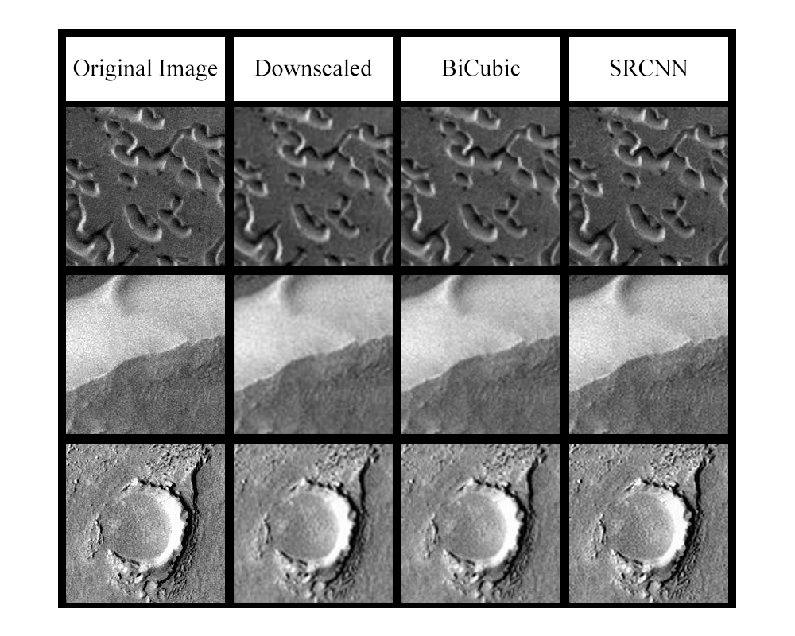

Comparison of original, downgraded, Bicubic and SRCNN images

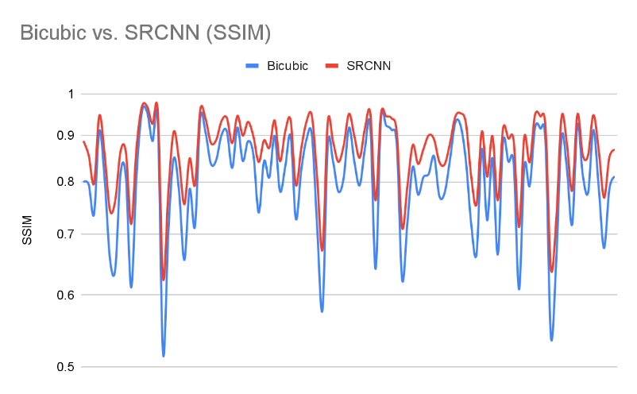

**SSIM Comparison of Bicubic Interpolation and SRCNN**

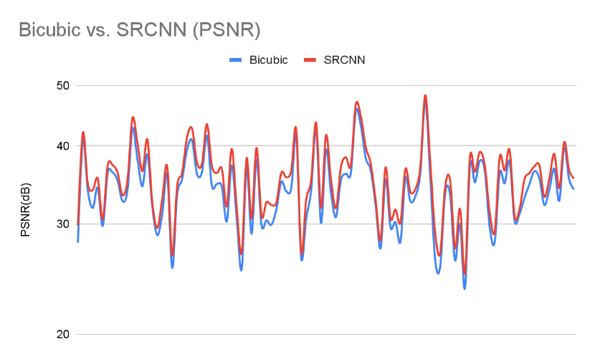

PSNR Comparison of Bicubic Interpolation and SRCNN

# 4.2 Super-Resolution Using a Generative Adversarial Network. (SRGAN)

SRGAN is a single-image super-resolution generative adversarial network that incorporates a perceptual loss function which includes both adversarial and content loss. For most picture graphics, it is one of the first strategies that allows the model to attain an upscaling factor of nearly 4x. SRGAN is useful because it automatically maximizes the peak signal-to-noise ratio by minimizing mean squared error (PSNR).

# 4.2.1 The Architecture

The Super Resolution GAN has two components: a generator and a discriminator. The generator generates data based on a probability distribution, while the discriminator tries to guess the data from an input dataset or generator. After then, the generator attempts to optimize the created data in order to deceive the discriminator. The following are the architectural details for the generator and discriminator:

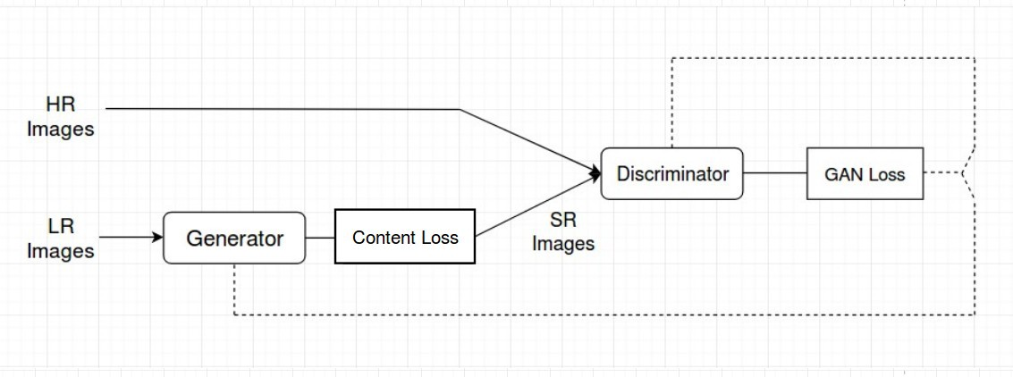

**Generator Architecture:**

The generator architecture contains residual network instead of deep convolutional networks because residual networks are easy to train and allows them to be substantially deeper in order to generate better results. This is because the residual network used a type of connection called skip connections.

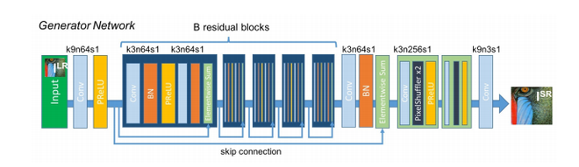B residual blocks (16) were generated by ResNet. Two convolutional layers with small 33 kernels and 64 feature maps are used in the residual block, followed by batch-normalization layers and Parametric ReLU as the activation function. Two trained sub-pixel convolution layers boost the resolution of the input image. Instead of employing a fixed value for a rectifier parameter (alpha) like LeakyReLU, this generator architecture uses parametric ReLU as an activation function. It learns the parameters of the rectifier over time and improves accuracy at a low computing cost. A high-resolution image (HR) is down-sampled to a low-resolution image throughout the training (LR). The image is then up-sampled from low resolution to super-resolution via the generator architecture. The image is then passed to the discriminator, which attempts to distinguish between a super-resolution and a high-resolution image and generates an adversarial loss, which is then fed back to the generator architecture.

**Discriminator architecture:**

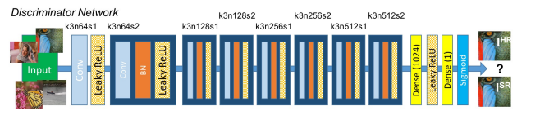

The discriminator's task is to discriminate the difference between real HR images and generated SR photos. The discriminator architecture applied in this study is similar to a DC-GAN design with LeakyReLU as the activation. The network has eight convolutional layers, each with 3X3 filter kernels, with the number of kernels rising by a factor of two from 64 to 512. When the number of features is doubled, strided convolutions are employed to lower the image resolution. To obtain a probability for sample classification, the 512 feature maps are followed by two thick layers with a leakyReLU applied between them and a final sigmoid activation function.

# 4.2.2 Loss Function:

The SRGAN uses perpetual loss function (LSR) which is the weighted sum of two loss components: content loss and adversarial loss. This loss is very important for the performance of the generator architecture:

1. **Content Loss:**

In this study, we apply two types of content loss: pixelwise MSE loss for the SRResnet architecture, which is the most common MSE loss for image Super Resolution; and pixelwise MSE loss for the SRResnet architecture, which is again common MSE loss for image Super Resolution. However, MSE loss will not be unable to deal with high frequency material in photos, resulting in too smooth images. As a result, the loss of several VGG layers is emplyed instaed. This VGG loss is based on the ReLU activation layers of the pre-trained 19-layer VGG network. This loss is defined as follows:

**Simple content loss:**

$$l_{MSE}^{SR}= \frac{1}{r^{2}WH} \sum_{x=1}^{rW}{\sum_{y=1}^{rH}{{\left(I_{x,y}^{H R}- G_{θ_{G}}{\left(I^{LR}\right)}_{x,y}\right)}^{2}}}$$

**VGG loss content:**

$$l_{VGG/ i,j}^{SR}=\frac{1}{W_{i,j}H_{i,j}}\sum_{x=1}^{W_{i,j}}{\sum_{y=1}^{H_{i,j}}{{\left(∅_{i,j}{\left(I^{H R}\right)}_{x,y}- ∅_{i,j}{\left(G_{θ_{G}}\left(I^{LR}\right)\right)}_{x,y}\right)}^{2}}}$$

1. **Adversarial Loss:**

The Adversarial loss is the loss function that forces the generator to image more similar to high resolution image by using a discriminator that is trained to differentiate between high resolution and super resolution images.

$$l_{Gen}^{S R}= \sum_{n=1}^{N}{-\log{D_{θ_{D}}\left(G_{θ_{G}}\left(I^{L R}\right)\right)}}$$

Therefore, total content loss of this architecture will be:

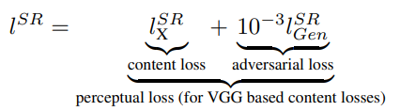

# 4.2 Super-Resolution Residual Neural Network (SRResNet)

# Chapter-5

**Hyperspectral imaging**

# 5.1 Introduction

To learn more about Mars, we must first understand how the colours exhibited in these photographs give information about chemistry and mineralogy, which in turn reveals information about the planet's climate and geologic history. Even in our daily lives, we have a colourful intuition for chemistry. When a damp piece of steel is exposed to air, the iron in the steel combines with oxygen to form rust, also known as iron oxide. We can tell if a piece of steel is spotted red with rust if it has been left out in the rain just by looking at it. Similarly, specialist field geologists can identify the hydrothermal minerals epidote and chlorite based on their green colour, and know that they developed in ancient conditions where hot water interacted with bedrock deep beneath. If they see blueschist, they know they're looking at rocks that formed during a tectonic event that built mountains.

Color observations by geologists are often used to enhance a variety of other mineral features such as crystal shape, hardness, texture, and geologic context. However, utilising an orbiting spacecraft or telescope to passively detect these additional fine features from hundreds or even thousands of kilometres away is impossible; we only have the luxury of viewing rocks up close on other planetary surfaces on rare occasions. As a result, colour is our most effective "remote" mineral diagnostic.

However, having the same colour as determined by human perception does not always imply having the same properties outside of the visible wavelength range. For example, the green minerals epidote and chlorite, reflect and absorb sunlight in distinct ways at longer wavelengths (in the infrared), which allows them to be separated. This wavelength-dependent behavior is the fundamental concept behind visible-near infrared reflectance

spectroscopy.

The chemical composition of a mineral often controls the wavelengths at which identifiable spectral characteristics appear. When sunlight strikes a mineral containing water molecules bound to its crystal structure, for example, some of the electromagnetic energy is absorbed by the water molecules, causing them to vibrate at a certain frequency. The energy of light that interacts with the water molecule to vibrate the hydrogen and oxygen bonds is transferred to that molecule and effectively converted to heat. As a result of this interaction, significantly less energy (light of that wavelength) is reflected off the mineral and returned to the camera. This reduction in reflected light at a certain wavelength is referred to as "absorption."

We can 'photograph' a planet's surface from space, with each pixel comprised of hundreds of observations of reflected light over the visible and infrared wavelength ranges (i.e., a spectrum), rather than just three red, green, blue i.e., in RGB channels or image planes. Based on analysis of the spectral shapes from different pixels, we may then select specific wavelengths (visible or infrared) to display in false colors so as to highlight interesting variability. In this somewhat abstract process, we are using two things we can see ourselves (color and geologic context) to observe things we cannot directly see: mineral make-up and – after careful analysis and interpretation – the long-vanished environments and geologic changes that occurred over vast stretches of time.

# 5.2 What is Hyperspectral imaging?

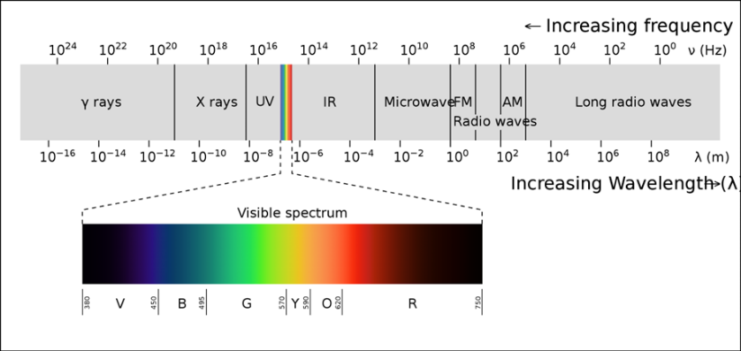Hyperspectral imaging collects and analyzes data across all regions of the electromagnetic spectrum. The objective of hyperspectral imaging is to collect the spectrum for each pixel in a scene image in order to locate objects, identify materials, and detect processes. Spectral imagers are divided into three categories. Push broom scanners and related whisk broom scanners (spatial scanning) read images over time, band sequential scanners (spectral scanning) acquire images of an area at different wavelengths, and snapshot hyperspectral imaging (which uses a staring array to generate an image in an instant) are all examples of spectral scanning.

Although the human eye perceives visible light color in three bands (long wavelengths as red, medium wavelengths as green, and short wavelengths as blue), spectral imaging splits the spectrum into many more bands. This technique of dividing images into bands can be extended beyond the visible. The recorded spectra in hyperspectral imaging have a precise wavelength resolution and encompass a wide range of wavelengths. Multiband imaging measures separated spectral bands, whereas hyperspectral imaging measures continuous spectral bands. Multispectral imaging and hyperspectral imaging are related. It employs wavelength ranges that are continuous and contiguous (e.g., 400 - 1100 nm in steps of 1 nm). Hyperspectral imaging produces the spectra of all pixels in a scene by photographing tiny spectral bands across a continuous spectral range.

# 5.3 MRO (Mars Reconnaissance Orbiter)

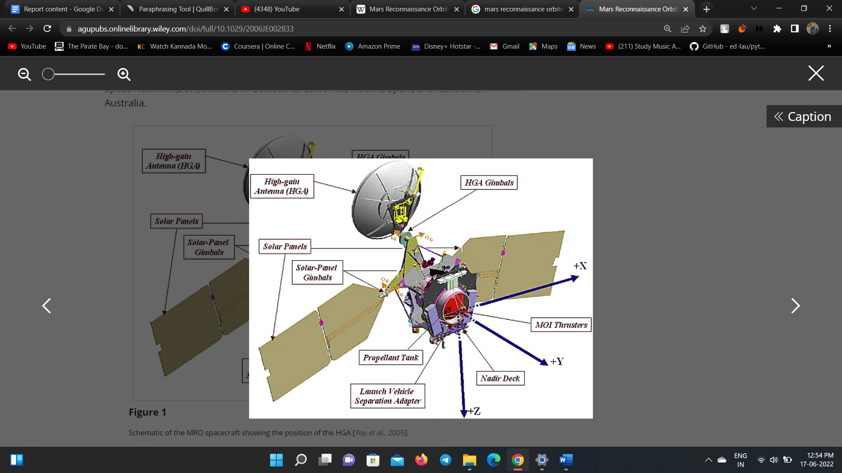

1. Since 2006, the Mars Reconnaissance Orbiter, or MRO, has examined the Red Planet's atmosphere and landscape from orbit, as well as operating as a critical data relay station for other Mars missions, such as the Mars Exploration Rover Opportunity.
2. The Mars Reconnaissance Orbiter, is equipped with a powerful camera called HiRISE that has aided in a number of discoveries, has returned thousands of high-resolution images of the Martian surface, which are assisting scientists in learning more about Mars, including the history of water flows on or near the planet's surface.
3. Three cameras, two spectrometers, and a radar are installed on MRO. Some of the equipment listed below gathered the mars image data utilized in our projects:

# 5.3.1 HiRISE (Camera):

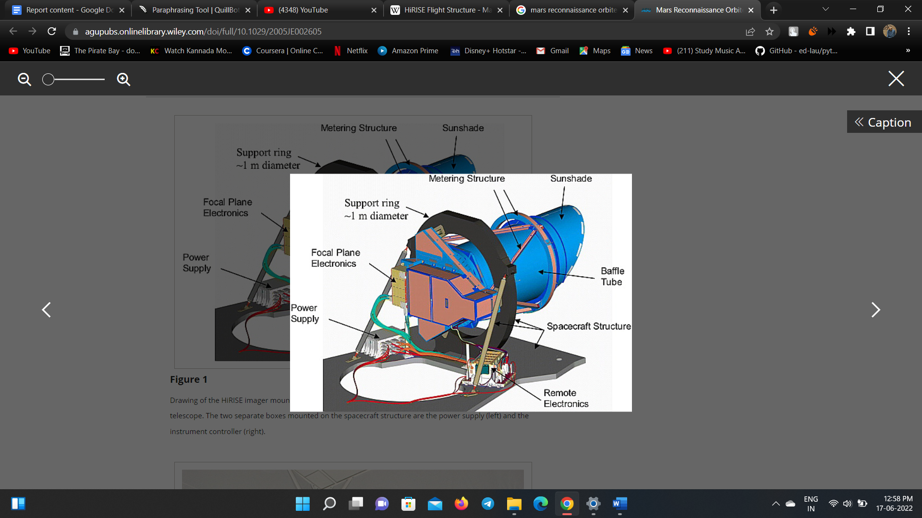

1. The HiRISE camera is a 0.5 m reflecting telescope, the largest ever carried on a deep space mission, with a resolution of or 0.3 m at a height of 300 kilometers.
2. HiRISE collects images in three color bands, 400 to 600 nm (blue–green or B–G), 550 to 850 nm (red) and 800 to 1,000 nm (near infrared or NIR).
3. The red color pictures are 20,264 pixels wide (6 kilometers), while the B–G and NIR images are 4,048 pixels wide (1.2 km wide).
4. HiRISE can create stereo pairs of images from which topography can be computed to an accuracy of 0.25 m, making it easier to map potential landing locations (9.8 in).
5. HiRISE Camera Capabilities at 300 km Altitude are listed in the table:

|  |  |
| --- | --- |
| **Parameter** | **Characteristics** |
| Ground sampling dimension | 30 cm/pixel (1 *μ*rad IFOV) |
| Resolution | ∼90 cm (3 pixels across an object) |
| Swath width (RED CCDs) | 6 km (1.14° FOV) |
| Color swath width | 1.2 km (0.23° FOV) |
| Maximum image size (pixels) | 20,000 × 63,780 (14-bit data) |
| SNR (anywhere on Mars in the optimal season) | From 90:1 to 250:1 in RED channels with TDI 128 and full resolution |
| Color band passes (at half maximum of Mars- and solar-weighted spectral response) | RED: 570–830 nm BG: <580 nm NIR: >790 nm |
| Stereo topographic precision | ∼25 cm vertical over ∼1 m2 areas |
| TDI lines | 8, 32, 64, or 128 |
| Pixel binning | none (1 × 1), 2 × 2, 3 × 3, 4 × 4, 8 × 8, 16 × 16 |
| Bits per pixel | 14, can be compressed to 8 via look-up tables (LUTs) |
| Compression (8-bit images only) | FELICS, compression >1.6:1 |

# 5.3.2 CTX (Camera):

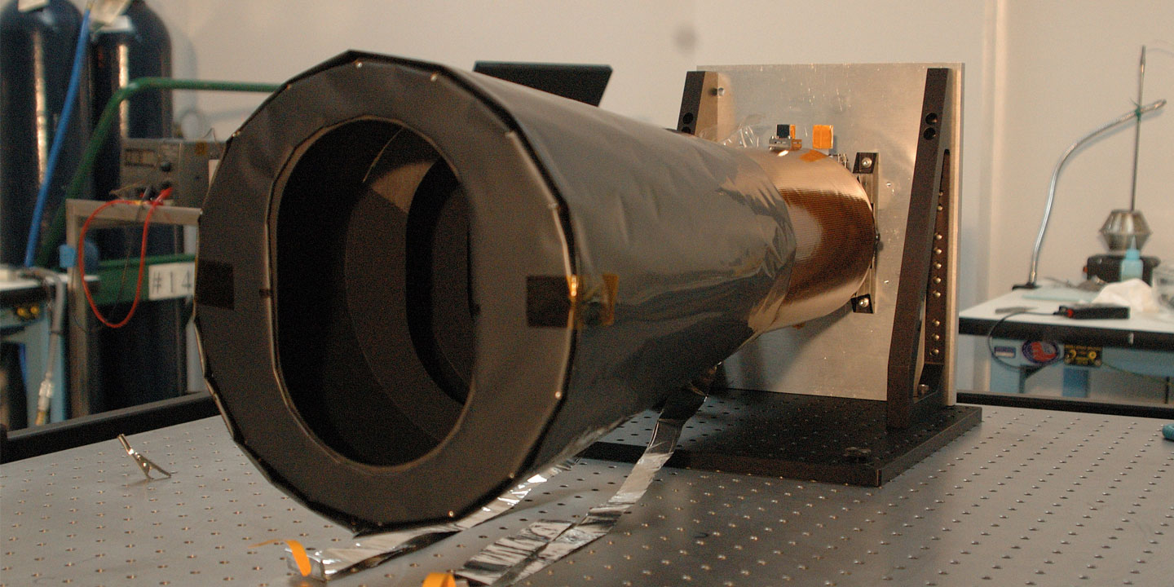

1. The Context Camera (CTX) produces grayscale images with a pixel resolution of up to 6 meters in a range of 500 to 800 nm (20 ft).
2. CTX is used to mosaic large areas of Mars, monitor a number of locations for changes over time, and obtain stereo (3D) coverage of crucial regions and prospective future landing sites, in addition to providing context maps for HiRISE and CRISM at targeted observations.
3. CTX uses a 350 mm (14 in) Maksutov Cassegrain telescope with a 5,064-pixel wide line array CCD as its optics.
4. The instrument captures images with a 30 km (19 mi) field of view and enough internal capacity to record images up to 160 km (99 mi) in length before loading them into the main computer.
5. CTX mapped 50% of Mars by February 2010.

# 5.3.3 CRISM (Spectrometer):

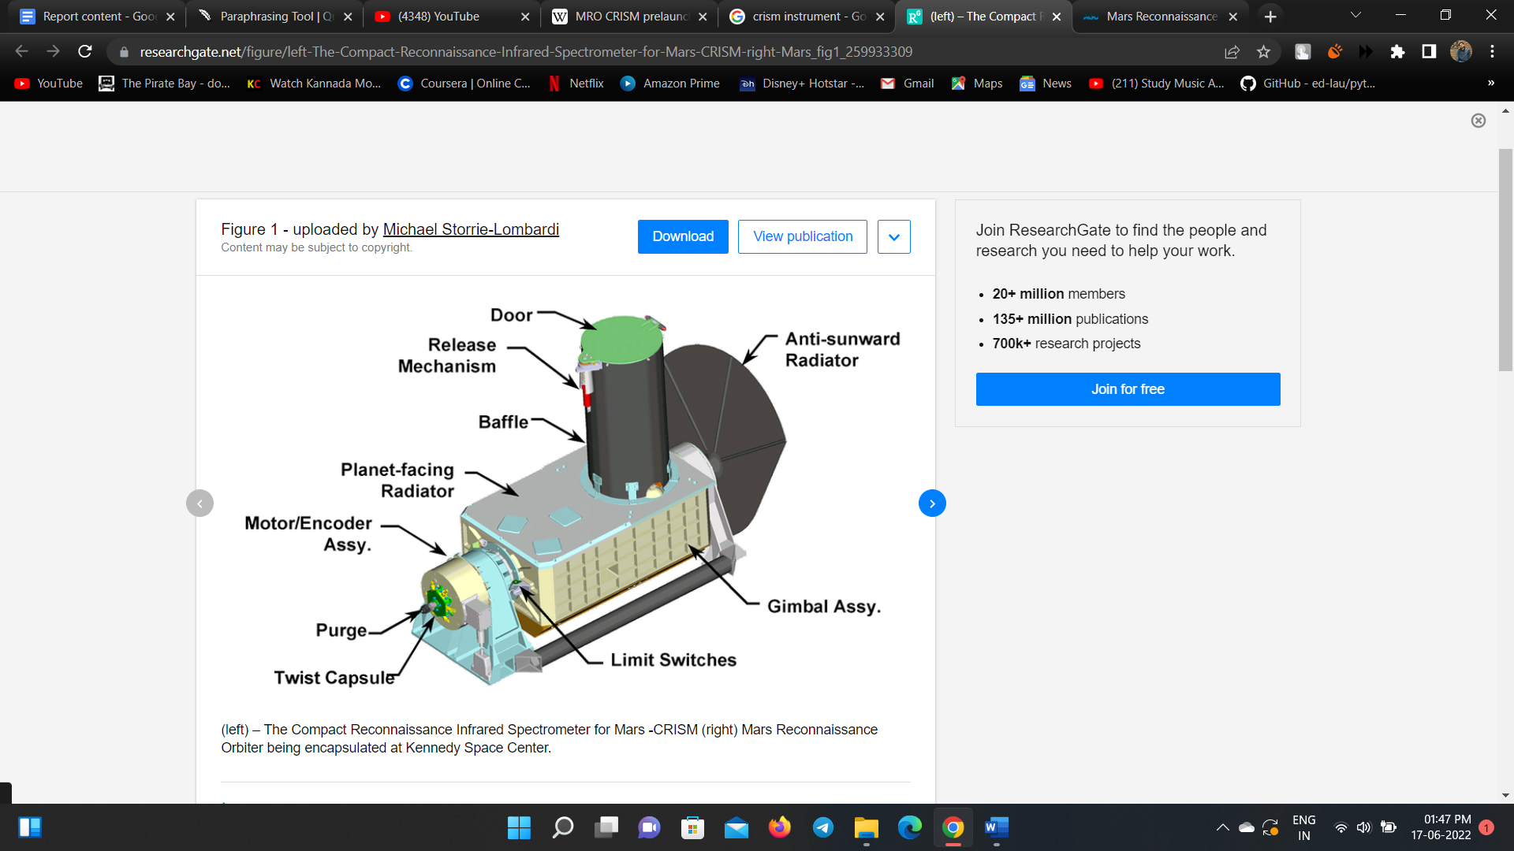

1. The Compact Reconnaissance Imaging Spectrometer for Mars (CRISM) is a visible and near infrared (VNIR) spectrometer that creates precise maps of surface mineralogy of mars.
2. It has a resolution of 18 m (59 ft) at an altitude of 300 km, operates from 370 to 3920 nm, measures the spectrum in 544 channels (each 6.55 nm wide), and works from 370 to 3920 nm (190 mi).
3. CRISM is being used to discover minerals and compounds that might indicate the presence of water on Mars' surface in the past or present. Iron, oxides, phyllosilicates, and carbonates are examples of materials with distinct patterns in their visible-infrared energy.

# 5.4 Data Set for Mineral Mapping

The CRISM (Compact Reconnaissance Imaging Spectrometer for Mars) instrument on MRO provided spectrum data from type spectra of phases identified in this dataset. This collection of spectra contains type locations for a wide range of currently recognized mineral spectral signatures. These type spectra, that make up the Minerals Identified through CRISM Analysis (MICA) library, are the product of more than seven years of CRISM data on Mars' surface, and they are the result of numerous researchers' work.

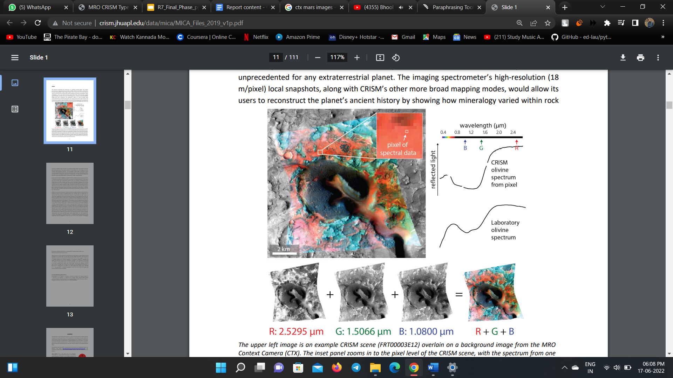

EDRs, DDRs, LDRs, and TRDRs are CRISM products provides raw and calibrated data with the geometric and time information required for map projection and post-processing correction. In summary:

1. Raw data is represented by EDRs, whereas calibrated data is represented by TRDRs. Both are measured in sensor space units. The optical and spatial aberrations existing at the sensor are recorded in them.
2. DDRs and LDRs are indexed to the wavelength bands of EDRs and TRDRs that are closest to 610 nm (VNIR) and 2300 nm (IR) for observations pointing at Mars' surface.

The MICA library or CRISM type spectra data consist of separate comma-delimited '.tab' files that include 7 columns including:

1. the wavelength array,
2. the CRISM ratioed I/F corrected type spectra data,
3. the CRISM ratioed I/F type spectra data,
4. the CRISM I/F corrected type spectra data (numerator),
5. the CRISM I/F type spectra data (numerator),
6. the CRISM I/F corrected data of spectrally-bland material (denominator), and
7. the CRISM I/F data of spectrally-bland material (denominator).

Due to a nonlinear decline in the spectral response towards the longest wavelengths of the VNIR detector, 'corrected spectra' have been modified to alleviate a minor variable offset at the join between the VNIR and IR detectors that remains near 1 micron. The offset was calculated using a fourth-order polynomial with an onset at 720 nm to multiply modify the VNIR reflectance until it matched the IR using nonlinear least squares fitting for extracted spectra between overlapping wavelengths in the VNIR and IR detectors. After rectification, a minor offset may still exist at the detector junction. To reduce the influence of remaining atmospheric and instrumental artifacts in the spectra, I/F spectra are ratioed to spectrally unremarkable material inside the same detector column.

# 5.5 ENVI

Harris Geospatial develops software for viewing, analysing, and managing geospatial images and scientific data. IDL, ENVI, and Jagwire are among the company's products, which are used in a broad range of sectors, including defence and intelligence, environmental, engineering, aerospace, medical imaging, and federal and civic governments across the world. For image processing and analysis software, ENVI is the industry standard. Image analysts, GIS experts, and scientists use it to extract fast, accurate, and reliable data from geographical imagery.

ENVI supports various types of data, including multispectral, hyperspectral, thermal, LiDAR, and SAR. It makes deep learning easily accessible and has user-friendly tools and procedures that do not necessitate programming. ENVI geospatial image analysis can be tailored to match this project requirements using an API and visual programming environment. ENVI is written in IDL, a strong programming language that allows users to modify and adapt ENVI's features and capabilities to meet our image analysis objectives and our project requirements. Image analysis features can be added to existing tools and models through customization, several tools with image analysis functions can be combined, and new bespoke mage analysis tools can be created depending on desired outcomes. Some of the tasks that can be performed using ENVI software is mentioned in the table:

|  |  |
| --- | --- |
| ANOMALY DETECTION  Search an image for statistical and spectral distinctions from the background landscape | CHANGE DETECTION  Look for areas of change by comparing two images from different dates using band ratio or feature index techniques |
| CLASSIFICATION  Classify terrain automatically or with user-defined specifications | **THEMATIC CHANGE**  Perform change detection between two classification results |
| FEATURE EXTRACTION  Find objects of interest using parameters based on spatial, spectral, and textural characteristics | **RPC ORTHORECTIFICATION**  Correct imagery to account for terrain and sensor distortion |
| IMAGE REGISTRATION  Improve the georeferencing of an image by tying it to an accurate base map | **VIEWSHED ANALYSIS**  Perform a line of site analysis |
| MULTISPECTRAL  A set of automated workflows designed to take advantage of multispectral imagery | **HYPERSPECTRAL**  A set of automated workflows designed to take advantage of hyperspectral imagery |

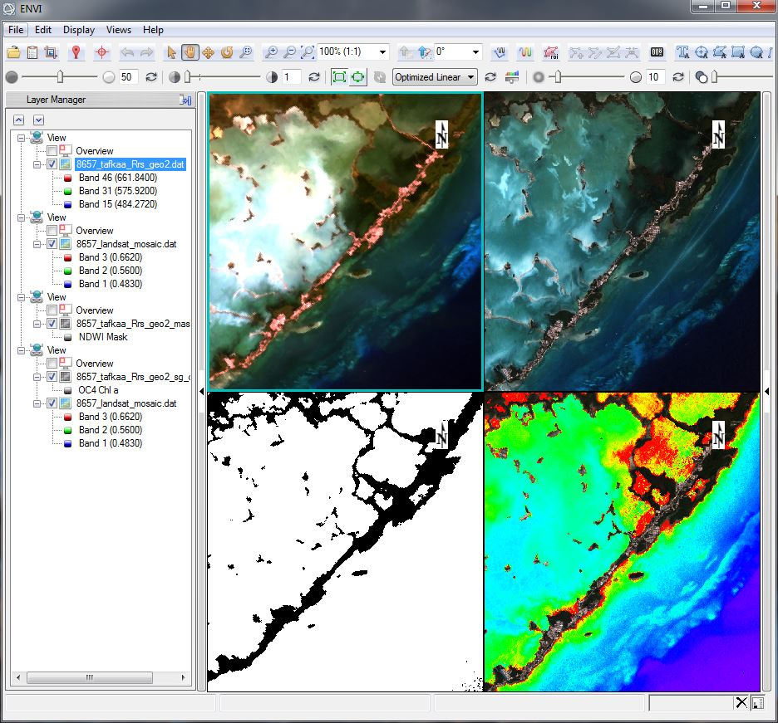

# Chapter-6

# Conclusions and Future Work

In this chapter, a brief conclusion of the proposed undergraduate project work that is being done / undertaken has to be presented here in this conclusion chapter.

The write-up must end with the concluding remarks-briefly describing innovations in the approach for how you are going to implement the taken up, main achievements and also any other important feature that makes the system stands out from the rest. This is one of the most important chapters and should be carefully written. Here, you evaluate your study, state which of the initial goals was reached and which not, mention the strong and weak points of your work, etc. You may point out the issues recommended for future work also here. State these clearly, in point-wise form if necessary, with respect to the original objective

The scope for future work has to be presented in brief so that it will be very much useful for the next year project students of the department.

**References**

The references should be numbered serially in the order of their occurrence in the text and their numbers should be indicated within square brackets for e.g., [3] and should be cited in the body of the text wherever it is applicable. The following **VTU-IEEE format (international standards)** to be used while mentioning the references for text books, journals & conference papers, websites, etc….

**Note 1 :** All the references has to be cited in the body of the report wherever you have used.

For text books –

[1]. Name of the author/s, “Title of the book”, *Name of the publisher*, *Address* / *country where Book is published*, Edition / Reprint, ISBN / ISSN, Cost of the book, Month & Year of publication.

For journal papers –

[1]. Name of the author/s, “Title of the paper”, Name of the Journal, *Country where journal is published*, ISBN / ISSN No., Impact Factor, Journal Paper No., Volume, Issue, page nos. (from-to), Month / Year of publication.

For conference papers –

[1]. Name of the author/s, “Title of the paper”, *Name of the Conference*, *Venue of the Conf*. / *Country where conference is conducted*, ISBN / ISSN No., DOI No., Conf. Paper id No., page nos. (from-to), Month / Year of publication.

For websites –

[1]. http://www.nptel.org

[2]. http://www.academics.org

For Books –

[1]. Name of the author/s, “Title of the book”, *Publisher name*, Place of publication with country name, ISBN/ISSN No., Edition / Reprint, No. of pages, Month, Year of publication.

[1]. Name of the author/s, “Title of the paper”, Name of the Conference, Venue of the Conference, paper id, pp. (from-to), Month, Year.

[2]. Name of the author/s, “Title of the paper”, Name of the Journal, Country of Publication, ISBN/ISSN No., paper id, Vol., Issue, Impact Factor, pp. (from-to), Month, Year.

[3]. Name of the author/s, “Title of the book”, Publisher name, Place of publication with country name, ISBN/ISSN No., Edition / Reprint, No. of pages, Month, Year of publication.

# Appendix

Data Sheets can be inserted here….

IC Pin Configurations

Charts

Software descriptions

Hardware descriptions

:

:

# Paper presented / Publications during the tenure of the UG program’s Project Work

A copy of the presented paper can be attached here ….. in the form of IEEE format & the full paper.

Format :

Name/s of the author/s, “Title of the paper”, *Name of the Journal / Conference*, ISBN, ISSN, Vol. xx, Issue/No. yy, pp. aa-bb, Month, Year.

# Awards and Recognitions

Certificate of participation, presentation can be inserted here.

Certificates of the project competitions won @ various colleges can also be inserted here.

# Photographs

Photographs can be put here …. Coloured & titled

# Plagiarism Report

Attach the plagiarism report here.

Plagiarism has to be checked from abstract to conclusions/future scope only & not the entire report.

# Instructions to the students

The students should follow the instructions while submitting the project report.

Get the project report checked from the concerned guide, after getting it approved with the sign, then only proceed towards the printing.

**No. of copies :** 1 to each student, 1 to guide, 1 to dept.

**No. of pages :** Minimum 100 pages

**Note 1 :** References to be in standard IEEE format only.

**Note 2 :** While presentation, follow the dress code with formals or uniform with ID card

**Note 3 :** All the mentioned items previously has to be started on a fresh page (*single sided*) or can be taken print out back to back (*double sided - would be better*), the contents of the items should be in 11 font, Book Antiqua, 1.5 line spacing, left margin 1.25 (*if single sided*, *else 1″ if doubled sided on both left and right margins*), right margin 1″, top & bottom margin 1″, A4 size paper, single sided matter, replace the contents given in the items with your work details. Every page should be paragraphed, indented & should contain minimum of 2-3 paragraphs. Each chapter should begin on a fresh page. The final corrected & approved project report should be taken a **laser print out (back to back or single side) on executive white bond paper,** **hard bounded** & submitted to the project guide / department project coordinator / project convener / Dept. HOD for final possible corrections, approvals, signatures & final submissions.

**Note 3 :**

All chapter headings – 18 Font.

All Sub-chapter headings or sub-sections – 16 Font.

All text-matter : 11 Font.

All figure & table titles : 10 Font.

All References : 10 Font.

Entire body of the report : 1.5 Line Spacing

For all the pages of the report, from the table of contents till the end, the header & the footer should be there, except for the title page of the project.

Page numbering should start from chapter-1, i.e., 1, 2, 3…. & the starting sheets should be numbered in roman numbers, i.e., i, ii, iii, iv, v,…..

Color of the outer cover/front page of the report : **PURPLE**

* All equation numbers should be numbered & right justified, the equation should be in the middle (use the middle tab) & the equation number to be at the right (use the right tab).
* The project report should be brief and include descriptions of work carried out by others only to the minimum extent necessary.
* Verbatim reproduction of material available elsewhere should be strictly avoided.
* Where short excerpts from published work are desired to be included, they should be within quotation marks appropriately referenced.
* Proper attention is to be paid not only to the technical contents but also to the organization of the report and clarity of the expression.
* Due care should be taken to avoid spelling and typing errors.
* The student should note that report-write-up forms the important component in the overall evaluation of the project
* Hardware projects must include : the component layout, complete circuit with the component list containing the name of the component, numbers used, etc. and the main component data sheets as Appendix.
* At the time of report submissions, the students must hand over a copy of these details to the project coordinator and see that they are entered in proper registers maintained in the department.
* Software projects must include a virus free disc, containing the software developed by them along with the read me file.
* Read me file should contain the details of the variables used, salient features of the software and procedure of using them: compiling procedure, details of the computer hardware/software requirements to run the same, etc.
* If the developed software uses any public domain software downloaded from some site, then the address of the site along with the module name etc. must be included on a separate sheet.
* It must be properly acknowledged in the acknowledgments.
* Sponsored projects must also satisfy the above requirements along with statement of accounts, bills for the same dully attested by the concerned guides to process further, they must also produce NOC from the concerned guide before taking the internal viva examination.
* The reports submitted to the department/guide(s) must be hard bounded, with a plastic covering.
* Buff sheets (separator sheets), used if any, between chapters, should be of thin paper (similar to the one which comes in transparency sheets in between) with the entire page written as chapter number, below the title of the chapter can be written.

**NOTE 4 :** **Students of the project batch should submit a CD / DVD containing all the works they have done, it should contain the following 40 items in different folders (all in w MSWord-COMPULSORY, pdf & .jpeg formats)**

1. Title sheet
2. Certificate
3. Acknowledgement
4. Abstract
5. Table of contents
6. Brief introduction of project work
7. Literature survey (soft copy of papers referred)
8. Methodology & working of the project work
9. Hardware & Software Tools used with interfacing & algorithms
10. Body of the report (chapter 1 to 7)
11. References with web links
12. Papers published
13. Codes (optional)
14. Simulation results
15. Photographs
16. GUIs
17. Softwares used
18. ppts of all the project reviews & the final ppt
19. A 6-8 page paper in IEEE 2 column format of the project work
20. Entire one file consisting of the entire report in word & pdf format.
21. Plagiarism report checked by Turnitin Software
22. Certificates of awards from project competitions
23. KSCST details
24. Project open day details, banners, photos, etc
25. Videos of the project working – 10 mins
26. *Technical seminar reports of all students in the project batch (single wise)-word & pdf*
27. *A 6-page paper in IEEE 2 column format of the technical seminar work*
28. *Reference papers used*
29. *ppts of the technical seminar*
30. Internship reports - word & pdf
31. A 6-page paper in IEEE 2 column format of the internship work
32. UG internship of all students in the project batch (single wise)
33. All the details of the company where the internship is carried out
34. Certificates of the internships carried out by the students
35. Swatch Bharath / Training / Innovation & Social Skills / MOOCs
36. Curricular activities
37. Higher studies admit card, admission order
38. Placement offers
39. CV / Bio-data
40. A good photograph

and the folders should contain the matter in it, the CD/DVD details should be written on the top of the CD with the project title, batch no. & the year, all the materials should be in **.**docx (word format) & as well as in **.**pdf format with jpeg files.

**NOTE 5 :** **Contents of the CD / DVD to be submitted (Word, Pdf, Jpeg, …)**

The CD/DVD should contain different folders in 1, 2, 3, 4, 5, 6, 7, 8, ….. inside which there should be sub-folders such as

**Folder 1 : UG Project (18EC8ICPR2) -** Title sheet, Certificate, Acknowledgement, Abstract, Table of Contents, Literature survey (soft copy of papers referred), Body of the report, References with web links, Papers published, Codes (not mandatory), Simulation results, Appendix, Photographs, GUIs, Software used, hardware & software tools used, ppts of all the Project reviews, **Video** of the project work 10-15 mins shot in a high end mobile, A 6-10 page paper in IEEE 2 column format of the project work, Certificate of company where project done, Entire one file consisting of the entire report in word & pdf format, One single file consisting of the entire project report in word & in pdf format, ***a sub- folder containing all the papers related to the project done for the literature survey.***

**Sl. Nos. 1 to 25**

**Folder 2 : UG Technical Seminar (18EC8ICTHS) –** All details w.r.t. the technical seminar of 2 credits to be put here similar to the folder 1, but with 4 different sub-folders (depending on the number of students in the project batch), each sub-folder should be named as student name inside which all the items should be present (word & pdf file), seminar ppt, A 6-10 page paper in IEEE 2 column format of the seminar work, ppts of the seminar presentations of all the students in the project batch.

**Sl. Nos. 26 to 29**

**Folder 3 : UG Internships (18EC8ICINT) –** All details w.r.t. the internship of 2 credits to be put here similar to the folders 1 & 2, but with 4 different sub-folders (depending on the number of students in the internship batch), each sub-folder should be named as student name inside which all the items should be present (word & pdf file), A 6-10 page paper in IEEE 2 column format of the internship work, ppts of the internship presentations of all the students in the project batch.

**Sl. Nos. 30 to 34**

**Folder 4 :** **Swatch Bharath / Training / Innovation & Social Skills / MOOCs (18EC8ICHSS)**

All details w.r.t. the Swatch Bharath / Training / Innovation & Social Skills / MOOCs / Certification courses attended / NPTEL courses done, the scanned copy of the training certificate (on-line or off-line), the reference materials, photographs, proofs for having attended.

**Sl. No. 35**

**Folder 5 : Activities (Curricular, Co-curricular & Extra-curricular) –** All details w.r.t. the activities in the form of certificates scanned such as workshops attended, prizes won, awards won, project competition & won in exhibitions, certification courses, courses attended, competition certificates won, etc...

**Sl. No. 36**

**Folder 6 : Higher studies –** All details w.r.t. the higher studies in the form of .pdf files such as admit cards, id cards, admission letters, passport, visa, fee receipts, etc….., .jpeg files to be put here.

**Sl. No. 37**

**Folder 7 : Placement –** All details w.r.t. the placement in the form of .pdf files such as offer letter, appointment orders, emails informations, the folder should contain all the off-campus letters & the on-campus letters also, etc….., .jpeg files to be put here.

**Sl. No. 38**

**Folder 8 : CV –** The entire CV / Bio-data of all the students in the project group named with USN & Student Name with photograph (all the 3 or 4 students in a sub-folder)

**Sl. Nos. 39 & 40**

**Folder 9 :** One-page Souvenir with all photos of students & abstract

**NOTE 6 :** **Checklist**

The student should submit a checklist, which should be verified from the project coordination team, CD & project report, Seminar report & Internship report collection team, duly signed & sealed, then only the HOD is going to sign the report.

Checklist to be submitted in the main project lab with Mr. Suresh Babu (Instructor, PE Lab) & get it verified, go to the respective project / seminar / internship guide, project convener & then only come to the HOD’s chamber for final signature.

**NOTE 7 :** **Header & Footer**

The heard & footer will be there for the body of the report only & not for the starting pages.

**Check List (tick the box)**

**(to be submitted to PE lab with the CD, copy of the project report)**

**Project Group :**

**USN/s :**

**Name/s of the student/s :**

|  |  |  |  |
| --- | --- | --- | --- |
| Folder-1 | **:** | UG Project (18EC8ICPR2) |  |
| Folder-2 | **:** | UG Technical Seminar (18EC8ICTHS) |  |
| Folder-3 | **:** | UG Internships (18EC8ICINT) |  |
| Folder-4 | **:** | Swatch Bharath / Training / Innovation & Social Skills / MOOCs (18EC8ICHSS) |  |
| Folder-5 | **:** | Higher studies |  |
| Folder-6 | **:** | Placement |  |
| Folder-7 | **:** | CV / Bio-Data |  |
| Folder-9 | **:** | One-page Souvenir abstract with all photos |  |
|  | **:** | Project report (with CD) |  |

**Name & Signature of the student 1 :**

**Name & Signature of the student 2 :**

**Name & Signature of the student 3 :**

**Name & Signature of the student 4 :**

**Signature of verifier (Mr. Suresh Babu) :**

**Signature of section i/c :**